ACTIVITIES 18TH OCTOBER
Warm up activities- Let’s see what you know
How many states do substances exhibit?
Can you name them?
Can you make an example for each state of water?
Which state has these characteristics?
• a rigid system;
• does not flow to take on the shape of a container;
• exhibits resistance to changes in shape or volume.
Which state has these characteristics?
• the particles are bound firmly but not rigidly;
• it is able to flow and take on the shape of its container;
• exhibits resistance to change in volume.
Which state has these characteristics?
• the intermolecular bonds are almost negligible in comparison to liquids or solids;
• it spreads out quickly from its initial position, this is called diffusion;
• has no fixed shape, the particles completely fill the container they are in.
Do you know the names of any changes of states?

Watch the video now and complete your answers.
https://www.youtube.com/watch?v=21CR01rlmv4

Watch slides 27-28-29-30 and do the activities:
1.Write the state next to the definitions
a. The large attractive forces between particles maintain the particles in dense and stable spatial arrangements, within which the particles vibrate around a fixed position. _________________
b. Particles are closely packed, but are far enough apart to slide over one another. __________
c. Particles are widely separated from one another, and move about at random due to their high kinetic energy. _________________
2. Write if the sentences are true or false:
-Ice is the solid state of water.
-Water at room temperature and 1 atm pressure is in the liquid state.
-Air is in the gas state at room temperature and 1 atm pressure.
3. Complete the definitions with the following words :
constant freezing temperature condensation melting sublimation vaporization heat energy
deposition pressure

A solid can be transformed into a liquid through ____________, and a liquid can be transformed into a solid through ____________.
A liquid can be transformed into a gas through ____________, and a gas can be transformed into a liquid through ____________.
A gas can be transformed into a solid through ____________, and a solid can be transformed into a gas through ____________.
The state of a substance is dependent on ____________ and ____________.
In order to change the state of a substance, it is necessary to transfer ____________ to it in the form of ____________.
The change of state of a substance occurs at ____________temperature

Remeber slide 32!!The changes of state of water as a function of time and temperature.
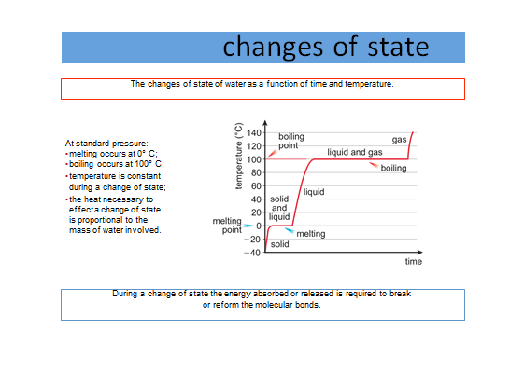

HOMEWORK : study the following tables:

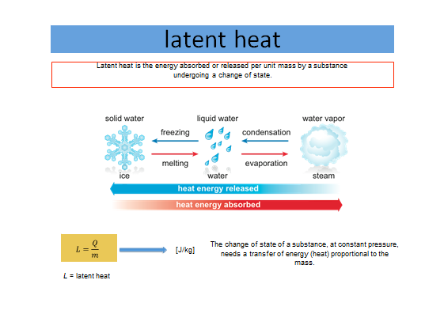

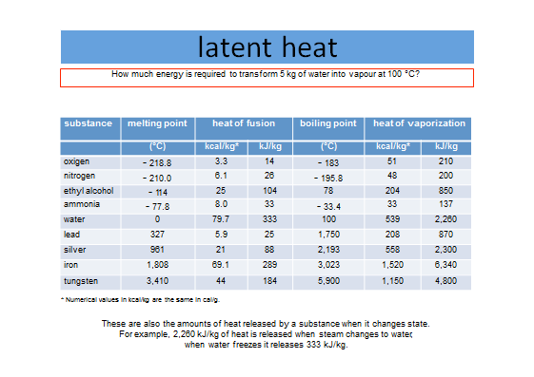
Write if the following sentences are true or false:
- In order to change the state of a substance it is necessary to transfer energy to it in the form of heat.
- 333 kJ/kg of energy is required to change steam into water.
- A substance is solid when its particles (atoms, ions or molecules) are far apart from each other and move about at random, due to their high kinetic energy.

Complete this change of state diagram. Write in the names of the states (on the dotted lines) and the state change processes (the small arrows). The grey dots in the boxes represent the atoms or molecules of the substance.
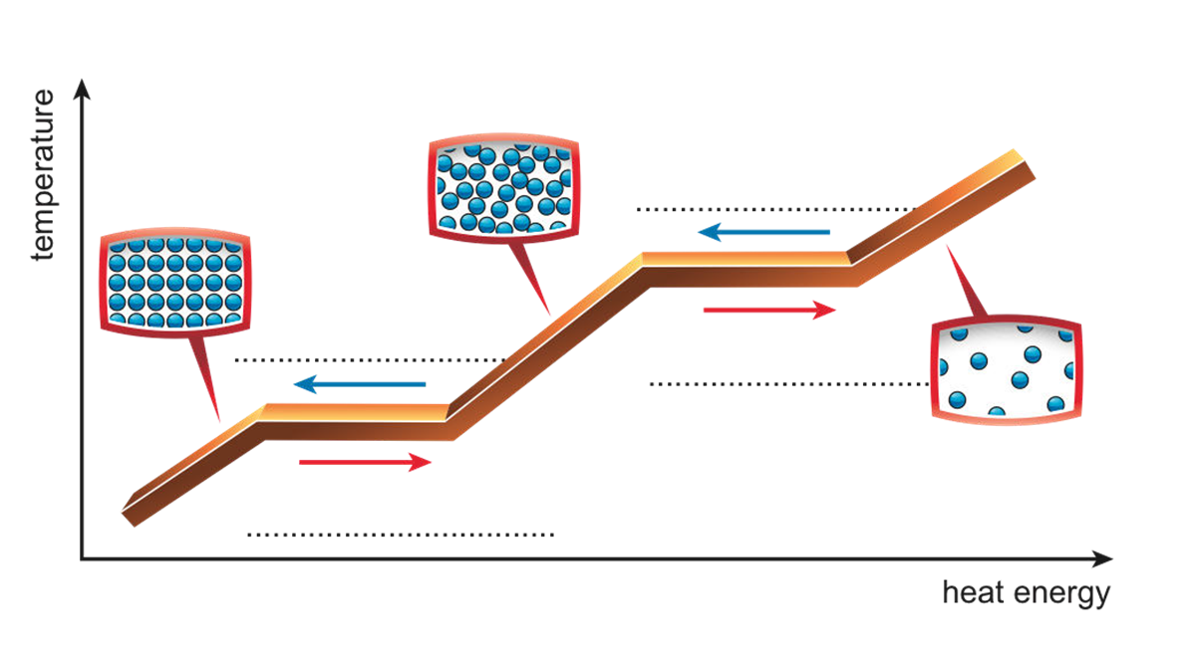

Construct the changes of state diagram for water
